Epithelial Tissue
Epithelial tissue (epithelium) forms the outer covering of the body and lines many internal body surfaces, cavities, ducts, and tubes. Its cells are closely packed together with very little intercellular matrix. The free surface of an epithelium faces either the external environment or a body fluid.
Epithelial tissue is broadly classified into:
- Simple epithelium
- Compound epithelium

Simple Epithelium
Simple epithelium consists of a single layer of cells. It mainly lines body cavities, ducts, and tubes. Based on the shape and specialization of its cells, it includes the following types:

1. Squamous Epithelium
- Squamous epithelium consists of a single layer of thin, flattened cells with irregular boundaries.
- It forms a thin surface that allows substances to pass through easily.
- It is found in the walls of blood vessels and the air sacs of the lungs, where it forms a diffusion boundary.
Main function: Diffusion and exchange.
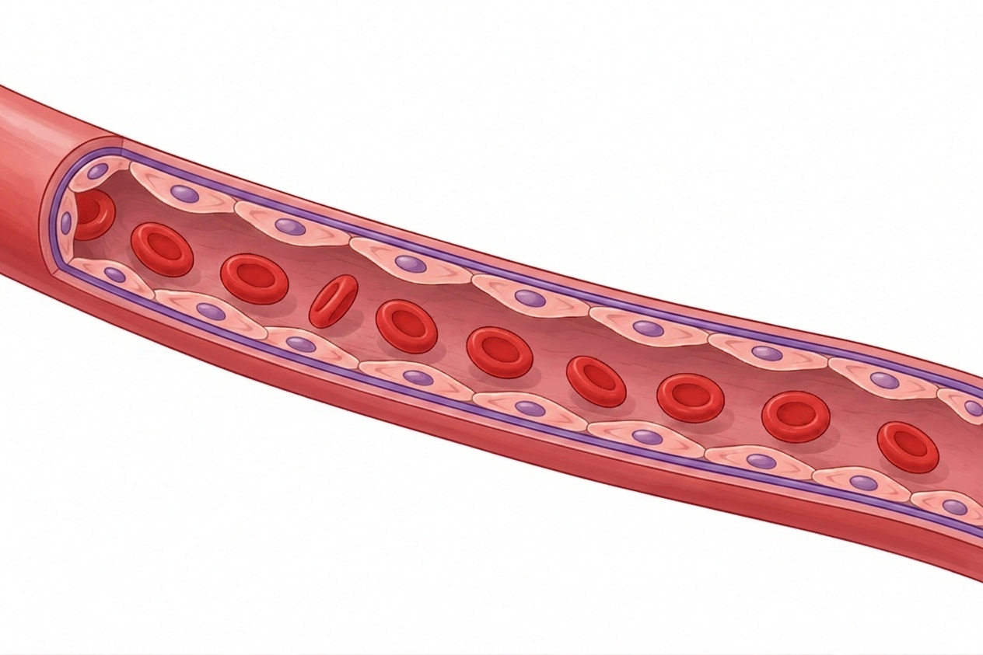

2. Cuboidal Epithelium
- Cuboidal epithelium consists of a single layer of cube-shaped cells.
- It is commonly found in the ducts of glands and the tubular parts of nephrons in the kidneys.
- It mainly performs secretion and absorption.
- The epithelial cells lining the proximal convoluted tubule (PCT) of the nephron possess microvilli, which increase the surface area for absorption.
Main functions: Secretion and absorption.
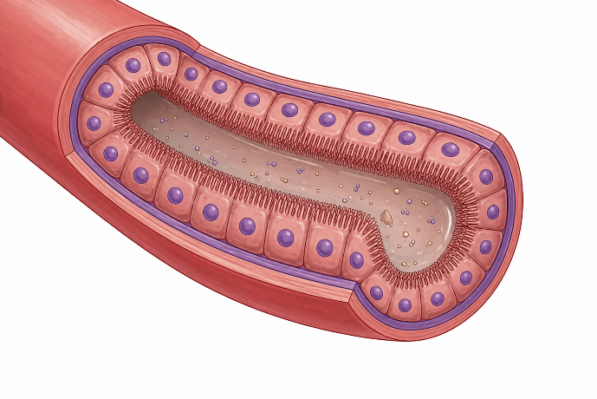

3. Columnar Epithelium
- Columnar epithelium consists of a single layer of tall and slender cells.
- Their nuclei are generally located toward the base of the cells.
- The free surface may bear microvilli.
- It lines organs such as the stomach and intestine.
Main functions: Secretion and absorption.
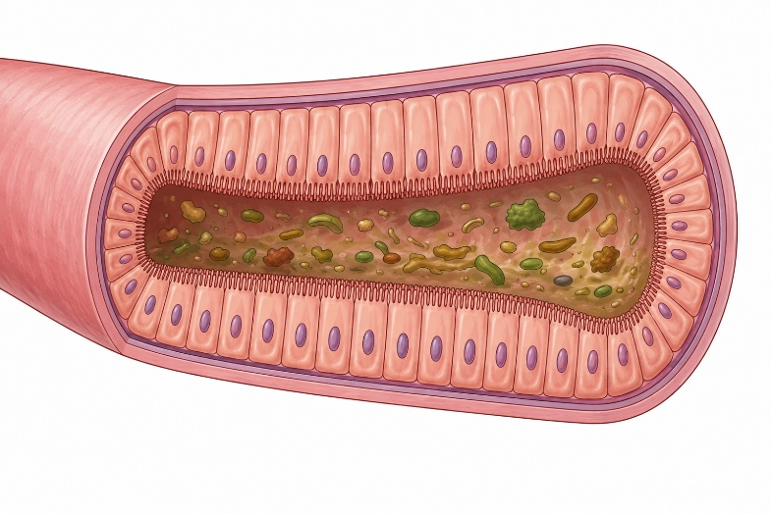

4. Ciliated Epithelium
- Ciliated epithelium consists of cuboidal or columnar cells that bear fine, hair-like cilia on their free surface.
- The cilia beat in a coordinated manner and move substances such as mucus or particles in a particular direction.
- It is found mainly in the inner lining of hollow structures such as the bronchioles and fallopian tubes.
Main function: Movement of materials across the epithelial surface.
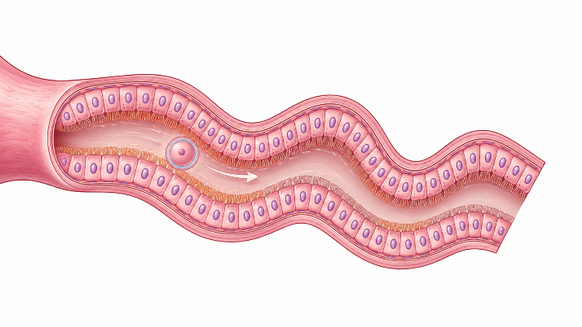

5. Glandular Epithelium
Some cuboidal or columnar epithelial cells become specialized for secretion. These cells form glandular epithelium.
Glandular epithelium can be classified based on:
A. Cell Accumulation
Unicellular
- Consists of single glandular cells.
- Example: Goblet cells in the alimentary canal.
Multicellular
- Consists of groups or clusters of glandular cells.
- Example: Salivary glands.
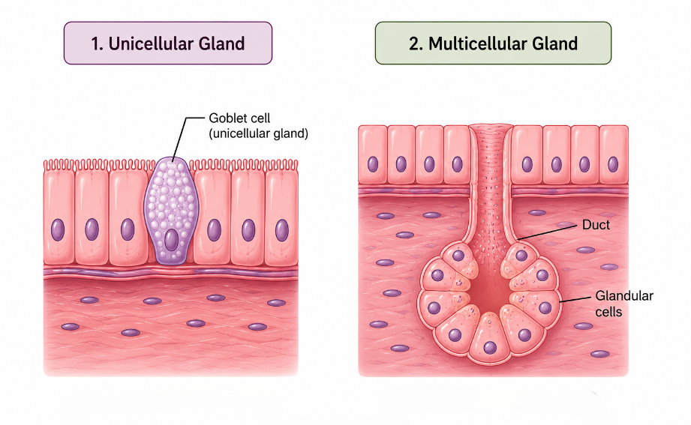
B. Mode of Secretion
Exocrine Glands
- Exocrine glands release their secretions through ducts or tubes.
- Their secretions include mucus, saliva, earwax, oil, milk, and digestive enzymes.
Endocrine Glands
- Endocrine glands are ductless glands.
- Their secretions, called hormones, are released into the fluid surrounding the gland and subsequently enter the circulation.
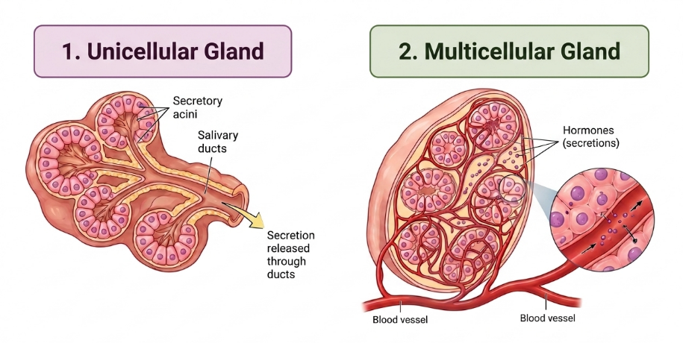

II. Compound Epithelium
Compound epithelium consists of more than one layer of cells. Because it has multiple layers, it is mainly specialized for protection rather than secretion and absorption.
It is found in:
- The dry surface of the skin
- The moist lining of the buccal cavity and pharynx
- The inner lining of salivary gland ducts and pancreatic ducts
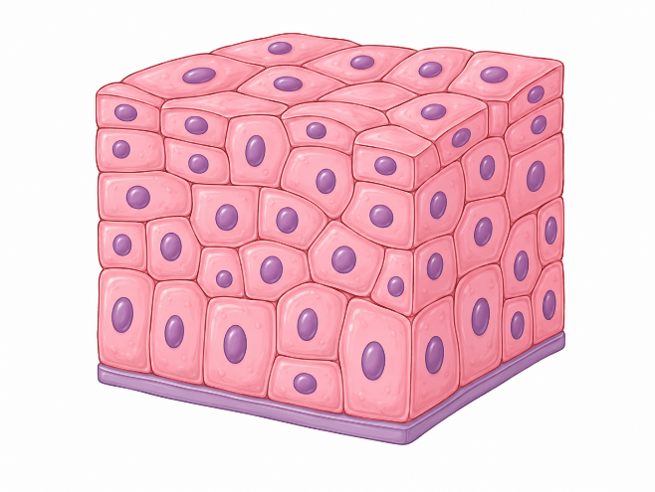

III. Cell Junctions
Now introduce cell junctions without repeating the general tissue definition from your introduction.
Cell junctions are specialized structures that connect neighboring cells and provide structural and functional coordination within tissues. They are particularly important in epithelial tissues, where cells are closely packed together.
Three major types of cell junctions are:
1. Tight Junctions
- Tight junctions form a close seal between neighboring cells.
- They help prevent substances from leaking between the cells.

2. Adhering Junctions
- Adhering junctions help cement neighboring cells together.
- They provide mechanical strength and maintain the structural integrity of the tissue.

3. Gap Junctions
- Gap junctions directly connect the cytoplasm of neighboring cells.
- They allow the rapid transfer of ions and small molecules between adjacent cells.
- They therefore help in communication between neighboring cells.
